Question. 1
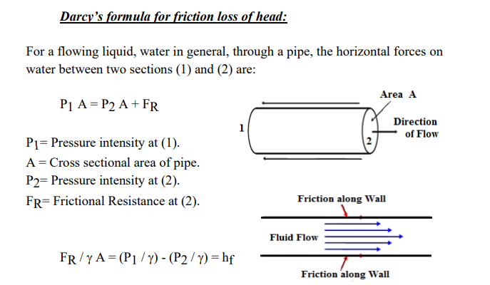
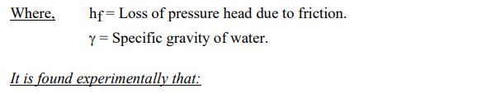
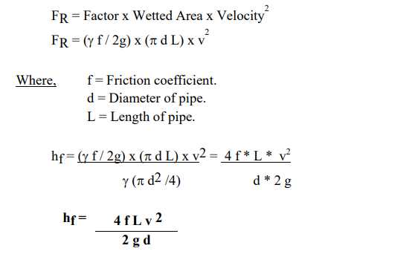

Qustion.2 Classification of pumps:
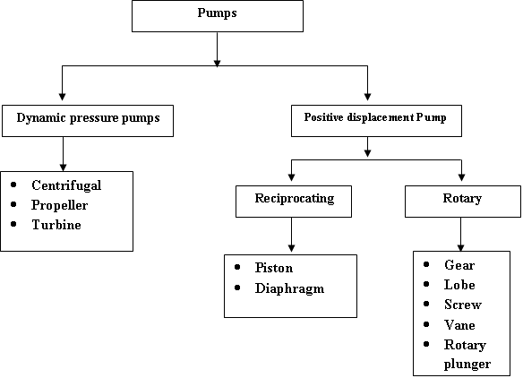
Question.3
Basic power symbols for hydraulic system components
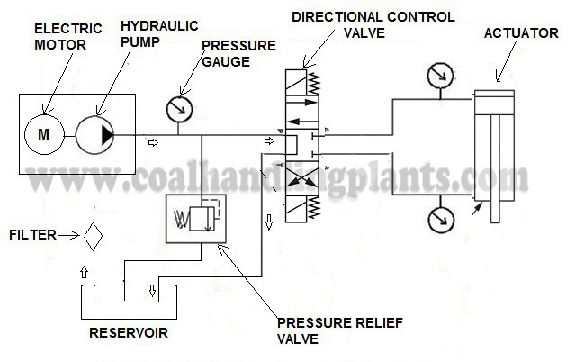
Question.4
Hydraulic Fluid is broken down into the following main categories:

Mineral oils – mineral oils are created as a result of refining crude oil and then improving their quality by adding certain substances. They may be labelled as HH which means that it’s a refined mineral oil that is non inhibited. HL has additives to make it anti corrosion and anti-rust. HM type has additives for anti-wear in addition to the additives of HL type.
Fire resistant fluids – there are 4 main types. HFAE is actually an oil in water emulsion. Type HFAB is a 40% water in oil emulsion. Type HRAS is a chemical solution in water and HFC is a water polymer solution containing water glycol. When a synthetic fluid is made from phosphate ester it’s known as type HFDR. HFDS is a synthetic oil that is made of chlorinated hydrocarbons.

Water / oil emulsions – this is when the predominant substance (around 60%) is the oil. Chemicals are used to enable the water to mix into the oil (also known as emulsify). When the fluid touches a hot surface, the water will turn to vapour and prevent a fire from occurring. This mixture also offers good lubrication properties.

Water glycol – known as HFC it comprises of 40% water mixed with 60% glycol. The result is a solution. This mix has the benefit of being able to work at a lower temperature than an emulsion whilst being able to produce an improved temperature viscosity trait.

Phosphate Esters - also known as HFDR these fluids are resistant to fire and will not ignite unless they reach above the temperature of 550°C. The main downside with them is their tendency to be chemically active which leads to them stripping paint and destroying rubber. This means that it’s necessary to use certain types of hoses, seals, etc that are able to withstand the chemical action. They can also melt the external insulation on electrical cables if they leak onto them. They are also known for being quite expensive.

When using hydraulic fluids, it’s critical that they are taken care of. Contamination accounts for up to 70% of faults in hydraulic system. It’s vital to avoid water, air and any solid matter from going into the fluid. This means that strict cleanliness is required when assembling units. Ideally it would take place in a dust free room that is designed to prevent contamination. After performing any work, a cleaning procedure should follow including the flushing of particles from pipes. Filtering systems should be used that can remove particles of between 3 microns to 10 microns (.001 mm = 1 micron).

Finally, due to the high expense of oil, it’s imperative to maintain it to provide a maximum life. Its condition should be checked regularly with records taken for each machine. Contamination should be avoided and filters used.

Question.5
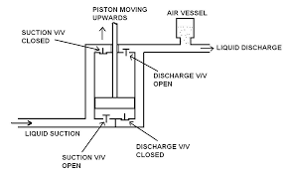
A piston pump is a type of positive displacement pump where the high-pressure seal eciprocates with the piston. Piston pumps can be used to move liquids or compress gases. They can operate over a wide range of pressures. High pressure operation can be achieved without a strong effect on flow rate. Piston pumps can also deal with viscous media and media containing solid particles. This pump type functions through a piston cup, oscillation mechanism where down-strokes cause pressure differentials, filling of pump chambers, where up-stroke forces the pump fluid out for use. Piston pumps are often used in scenarios requiring high, consistent pressure and in water irrigation or delivery systems.

Qusetion 6

Vane pumps:
The vane pump consists of a rotor, carrying a number of sliding vanes, rotating in a circular housing. With the rotor being eccentric to the casing, oil is transmitted in the vane spaces across the pump from the suction to the discharge port.
The vanes are acted on by centrifugal force when the unit is rotating, but in order to reduce leakage at the tips it is common practice to pressure load them (by supplying discharge pressure to the base of the vane slots) and sometimes to spring load them against the track. As with the gear unit, control of the clearances at the sides of the rotor assembly is most important.

The balanced design in Figure 3 eliminates pressure loading on the bearings and uses an elliptical vane track with the vanes moving in and out twice each revolution. There are diametrically opposed suction ports and discharge ports as shown in Figure 3 and these are connected together in the cast body. This pump is only available as fixed displacement.

Vane pumps are inherently more complex than gear pumps, they contain a greater number of components and are, therefore, more expensive. However, vane pumps operate at much lower noise levels than gear pumps and their cost can be offset against their good serviceability, which is not available with gear type pumps.

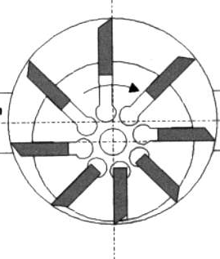
Figure 4 Variable Displacement Vane Pump.

Variable displacement vane pumps are available as shown in Figure 4 where the centre of the rotating vane block can be moved in relation to the centre of the housing. Unlike the balanced vane unit of Figure 3, these are single acting and, as a consequence, there is an unbalanced pressure force on the rotor so that the bearing size has to be increased in order to obtain adequate life.

Question 7:
The Reynolds number is the ratio of a fluid's inertial force to its viscous force. Inertial force involves force due to the momentum of the mass of flowing fluid.
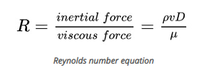

If the Reynolds number is less than 2300, the flow is laminar. Any Reynolds number over 4000 indicates turbulent flow. In between these values indicates transient flow, which means the fluid flow is transitioning between laminar and turbulent flow. This usually happens only for a short period of time at the beginning or end of fluid flow when a valve or faucet is turned on or off. Let's look at the equation for the Reynolds number.
Pascal's principle is defined as “a change in pressure at any point in an enclosed fluid at rest is transmitted undiminished to all points in the fluid”.

